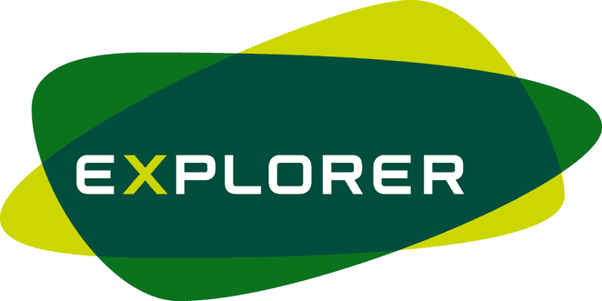 EXPEDITION MENU PLANNING ADVICE

Food should be:
A GOOD HIGH ENERGY CONTENT- average energy requirements will increase by 60% on an expedition and if weight and/or bulk is a problem then the food should be energy dense, e.g. chocolate, cheese, dried fruit, nuts, tinned meat or fish, biscuits.
LIGHTWEIGHT- very important when you have to carry food yourself. Where possible choose freeze dried foods. Don't end up carrying extra water, you can usually find it at the end of the day in your camp site.
EASY TO PACK AND EASY TO PREPARE- many packs only need water added and cook in 5 minutes.
TASTY, APPEALING AND VARIED- this is essential because food is no good unless it is eaten. Boring food will reduce appetites, something which you cannot afford to happen when energy requirements are so high.
NUTRITIONALLY BALANCED -this becomes more important as the length of the trip and /or the physical difficulty increases. If the expedition is particularly strenuous or long, having enough energy, carbohydrate and fluid is essential if you want to keep going.

Staying Hydrated
Ideally you should drink before you feel thirsty, about 200mls of water every half hour. Approximately 2 litres a day should be sufficient. At campsites you will have an adequate supply for all your cooking and washing up.
Types of expedition foods
THESE ARE THE BEST TYPES OF THINGS TO BUY:
Freeze dried ready meals, porridge oats, rice, pasta, instant mashed potato, dried soups, tinned meat, tinned fish, cured ham, cheese, beans, dried milk, hot chocolate, sugar, syrup, condensed milk, margarine, oil, tinned fruit, muesli bars, toffees, chocolates, boiled sweets, dried fruit, nuts, biscuits, crackers, jam, chocolate spread, peanut butter. N.B. no glass jars and no tins. Transfer the contents to good quality double freezer bags.

Example menu:
Breakfast Porridge mix with sultanas, sugar, milk powder and ground almonds. (mixed before departure in individual freezer bags-120g) Mug of Tea, Mars Bar

Snacks Power Bar, Dried Apricots or Dates (100g), Jelly Babies(85g), Mixed salted nuts (100g) - 1000 calories!

Evening Noodles x 2, Small Chorizo sausage x 1, warm pudding,
Meal Hot Chocolate

3500-4000 calories per day + you feel full!

The general philosophy for expedition food is to travel light and keep to a high carb and varied diet that is simple to prepare.

