**Canoe Club ‘Three Weirs’ Trip**

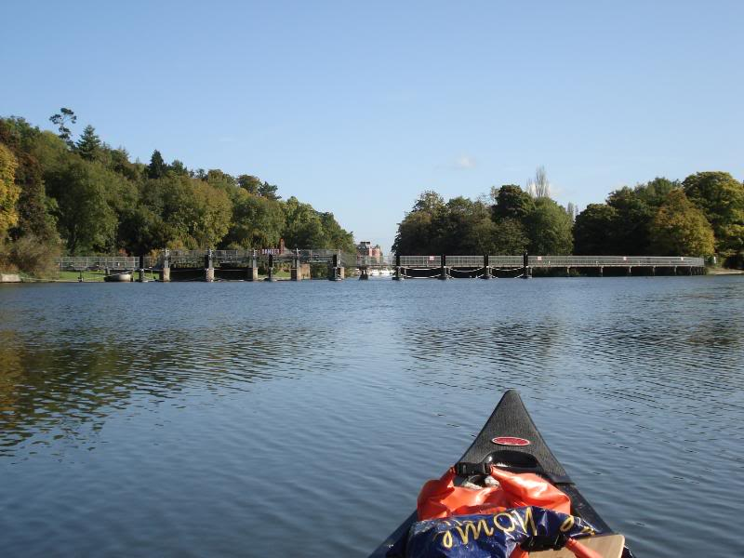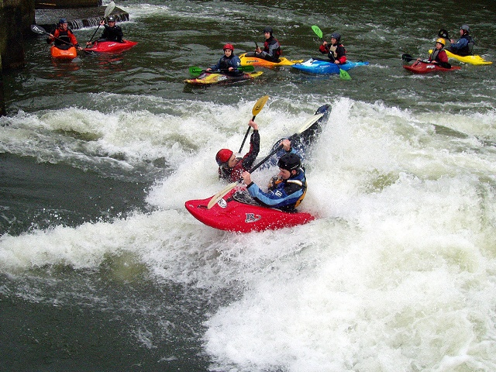

This is a trip From Hurley, Nr Henley-on-Thames, to Marlow

This is a beautifully scenic trip which also includes the three Weirs of Hurley, Temple and Marlow.

The minimum standard for this trip is BCU 1 star award or paddlepower passport plus experience of paddling 5Km.

The trip is a joint activity with Hertfordshire Scouts and will be supervised by a full coaching team. Helmets and equipment will be issued for the weir sections and Boat, paddle, buoyancy aids will need to be pre-booked to ensure that we have the correct numbers there.

Meeting will be at 8am at the boathouse and you should expect to be back approximately 5pm further details on the day will be available on request

Cost of this trip will be £12.50 (or £7.50 for club members)

Please bring with you a packed lunch including some extra snacks for the river, a hot drink and possibly a cold drink depending on the weather.

This is a very unpredictable trip for weather; some years have been blazing sunshine and a chance to top up the sun tan and other years have been cold, wet, and very grey. Please make sure that you have clothing and food for the worst of weather, that way it’s always a pleasant surprise when it’s nice and sunny!

Below, please indicate if you would like to go and what items of equipment you will need to use from the club:

*Cut here*………………………………………………………………………………………………………………*Cut here*



Please book me on the 3 weirs trip on 10th May

**Equipment Required**

Kayak……… Y/N

Paddle……... Y/N

Buoyancy Aid… Y/N

Helmet………… Y/N

Cag ………….. Y/N

Spray Deck.…. Y/N

*Circle for yes or no*

Name: _______________________________

Emergency contact name: _____________________ Phone Number: _____________________

I would like the Leaders / Instructors of the club to be aware of the following medical conditions

that may affect my son / daughter whilst participating in water activities.

( ie; asthma, epilepsy, nut/sting allergies )

|  |
| --- |
|  |
|  |
|  |

Signed: (Parent/Guardian/over 18) _________________________________